- Networks Cables & Connectors

Q.1 Draw a labeled diagram of a Cat6 Ethernet cable, showing the color order of wires in the T568B standard and labeling the RJ-45 connector pins?

Answer

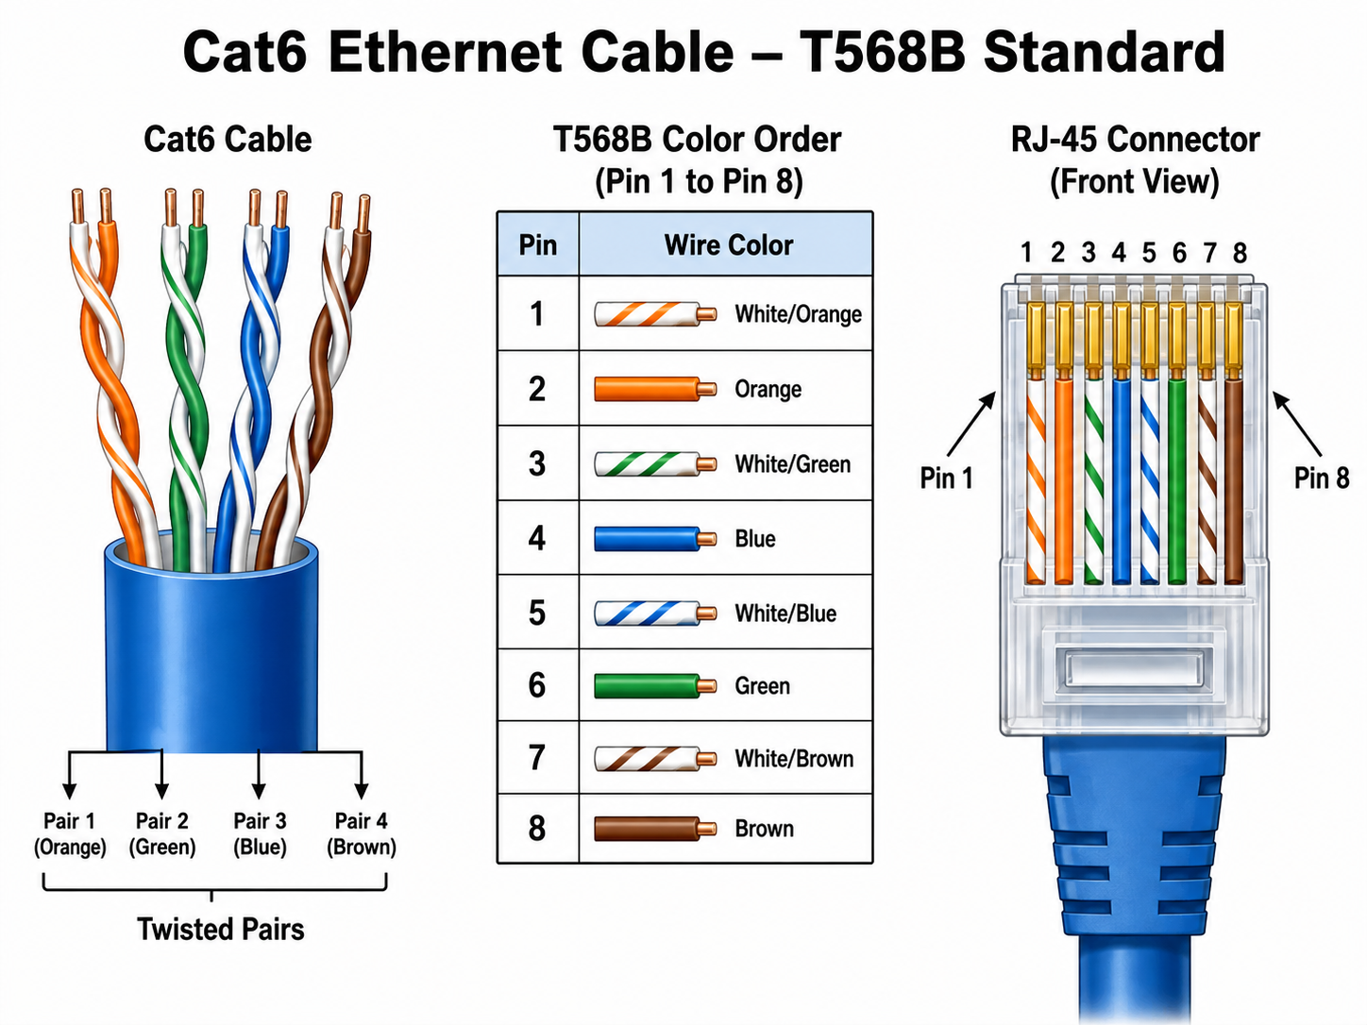

- The diagram shows a Cat6 Ethernet cable using the T568B wiring standard. The RJ-45 connector has 8 pins, and each pin is connected to a specific wire color. The correct order is White/Orange, Orange, White/Green, Blue, White/Blue, Green, White/Brown, and Brown. This standard is commonly used for Ethernet network connections.

Q.2 List three types of network cables (such as Cat5e, Cat6, and fiber optic) and for each, mention one real-world app or device (like a WiFi router, Zomato POS terminal, or IPL streaming server) where it would be used, explaining why?

Answer

- Types of Network Cables and Their Uses:

- Cat5e Ethernet Cable:
Example: WiFi router connected to a computer.
Reason: Cat5e supports good internet speed and is commonly used in homes and small offices. It can support speeds up to 1 Gbps.
- Cat6 Ethernet Cable:
Example: Zomato POS terminal connected to a router or network switch.
Reason: Cat6 provides faster and more stable network connections. It can support higher speeds and has less interference compared to Cat5e.
- Fiber Optic Cable:
Example: IPL streaming server in a data center.
Reason: Fiber optic cable provides very high-speed data transfer over long distances. It is suitable for servers and places that require large amounts of bandwidth.

Q.3 Watch a YouTube video showing how to crimp an RJ-45 connector onto a network cable, then write down the step-by-step process in your own words and mention two common mistakes to avoid?

Answer

- Steps to Crimp an RJ-45 Connector
The general process of crimping an RJ-45 connector is:
- Cut the Ethernet cable to the required length.
- Remove about 2 to 3 cm of the outer cable cover.
- Separate and untwist the four pairs of wires.
- Arrange the wires in the correct T568B color order.
- Straighten all the wires properly.
- Cut the wire ends evenly.
- Insert all 8 wires into the RJ-45 connector.
- Check that every wire has reached the end of the connector.
- Put the connector into the crimping tool.
- Press the crimping tool firmly.
- Test the cable using a LAN cable tester.
- Two Common Mistakes to Avoid
- Wrong wire order: The cable may not work if the T568B color order is incorrect.
- Wires not fully inserted: If the wires do not reach the end of the RJ-45 connector, the connection may become weak or fail.

Q.4 Given the following scenario: You are setting up a gaming zone for an IPL screening event and need to connect multiple screens and consoles. Choose the appropriate cable and connector types for high-speed, reliable connections, and explain your choices?

Answer
- Gaming Zone for an IPL Screening Event

    - For a gaming zone, I would use Cat6 Ethernet cables with RJ-45 connectors to connect gaming consoles, PCs, streaming devices, routers, and network switches.
    - I would choose Cat6 because it provides a fast and stable wired connection. It also reduces lag during online gaming and helps provide smooth streaming.
    - To connect gaming consoles or PCs to TV screens, I would use HDMI cables because HDMI can carry both high-quality video and audio.
    - A network switch with RJ-45 ports can also be used to connect many consoles and computers to the same network.
    - Therefore, Cat6 with RJ-45 connectors is a good choice for networking because it provides high speed, low delay, and reliable performance.

Q.5 Find and share a photo (from your home, college, or online) of any network cable or connector in use (such as behind a WiFi router or at a café's POS counter), and describe what type it is and what devices it connects.<br><br><em><strong>Hint:</strong> Look for blue or yellow cables with clear plastic ends (RJ-45) or thin round cables for fiber optics.</em>?

Answer

- Network Cable or Connector in Use

- Type: Cat6 Ethernet Cable with RJ-45 Connector
- This is a Cat6 Ethernet cable connected to a WiFi router. The cable has a clear plastic RJ-45 connector at the end.
- It is used to connect the WiFi router to another device such as a computer, modem, smart TV, or network switch.
- This type of cable provides a fast and stable wired internet connection.
